AP Biology Summer Assignment

Mrs. Slomnicki

You will be accessing your summer assignment through Google classroom. I encourage you to join our class immediately. You will also be using this website throughout the year to access learning videos, at-home quizzes, and other assignments.

The join code is an3liyp

Your summer assignment is (or, will be) uploaded onto Google classroom. There will be two parts:

A review of graphing skills. This will be accomplished through portions of actual free response questions that will be assigned through the Google classroom.

The first unit that we cover is Ecology, and your summer assignment will require you to learn sections of this topic on your own. I posted videos on the Ecology information on Google classroom along with accompanying note packets for you to print out. You must take notes in the note packets while watching these videos. In addition, there is a short quiz posted on Google classroom corresponding to each video. I will only briefly review the contents of these videos in class upon our return, I will not re-teach the material. There will be additional Ecology material that I will teach you in class.

My recommendation would be to complete the graphing packet earlier, and save the ecology videos closer to when you return to school- I want to make sure the material is fresh in your head. (Don't leave them all until the night before school starts, though- you will be overwhelmed!).

There is no AP Biology textbook that you will be given

.

Don't hesitate to be in touch if you have any questions. Wishing you all a relaxing and enjoyable summer. I'm looking forward to teaching you next year, and hope you are looking forward to working hard, being challenged, and learning a great deal of exciting material!

What’s the Format of the AP Biology Exam?

The AP Biology Exam is 3 hours long. Like other AP tests, it has two parts, a multiple choice section and a free response section (each of which is worth 50 percent of your score), although these sections are divided further into different types of questions.

The multiple choice section has 60 multiple choice questions. This section is one hour and 30 minutes total. Each multiple choice question has four choices.

The free response section has six questions total: four short response questions and two long response questions. This section takes up the remaining hour and thirty minutes of time. There is a 10 minute reading period at the beginning of the free response section.

What Do Questions Look Like on the AP Biology Exam?

Here’s an example of a multiple choice question you might see on the AP Biology exam:
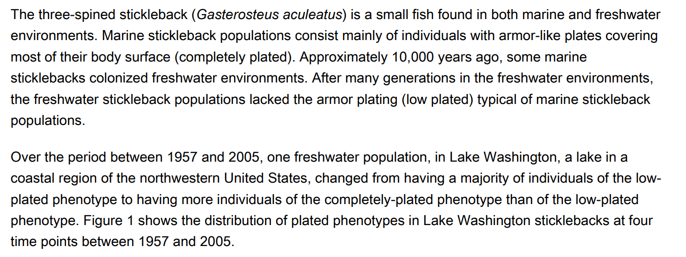
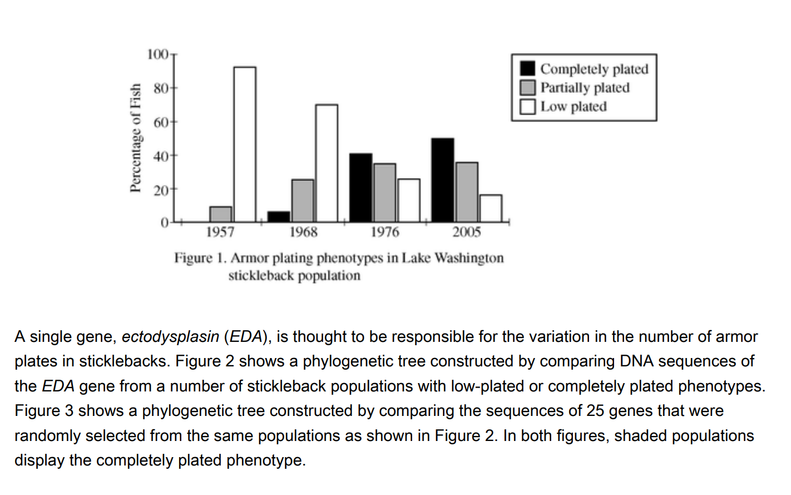
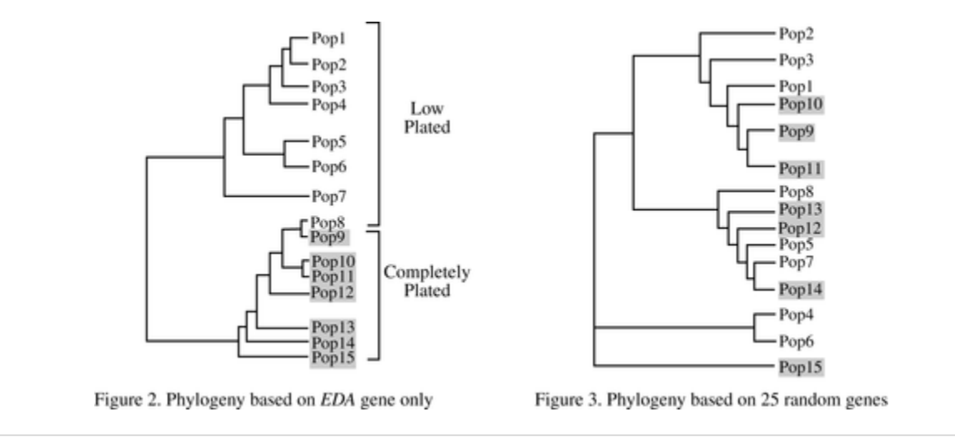

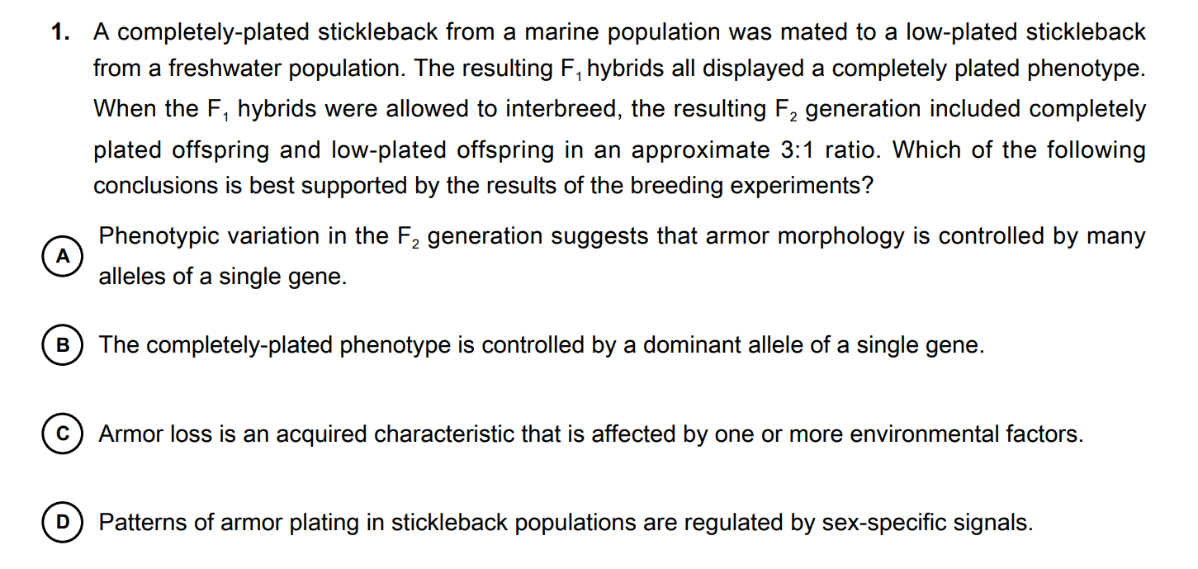

The answer is B

Here’s an example of a short free response question:

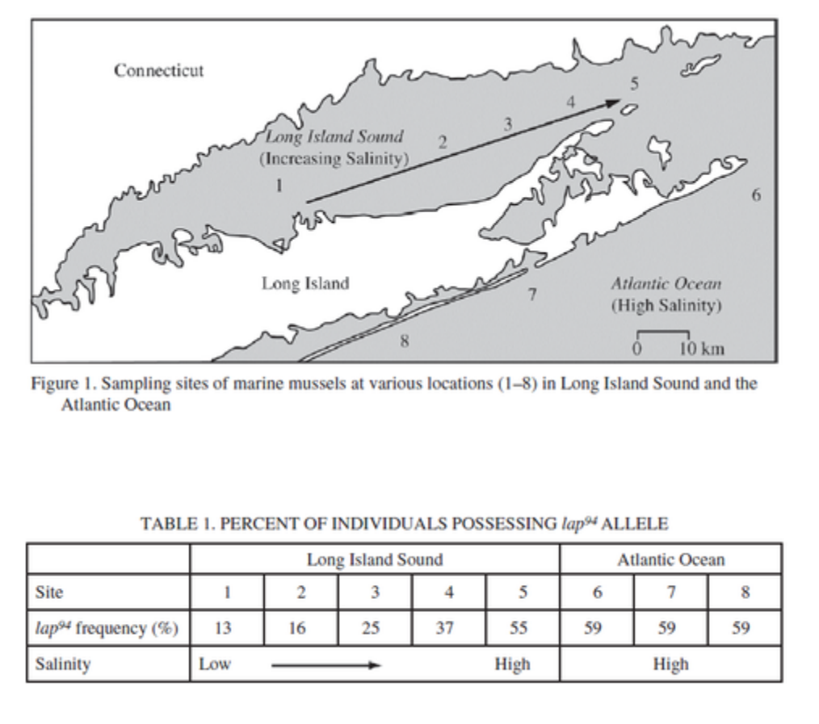
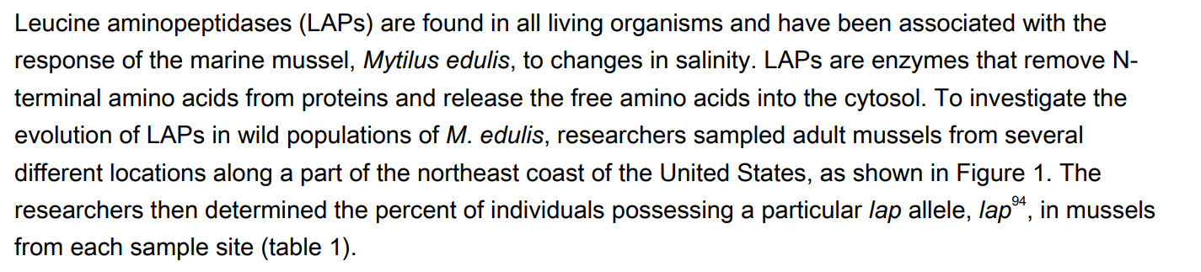

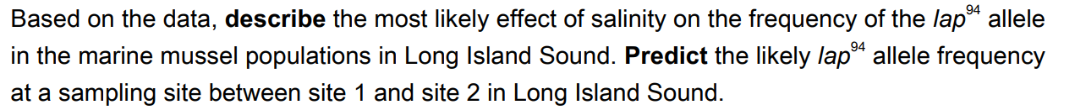

To get the correct answer, you have to know the facts about water potential, genetics, and evolution but you also need to be able to apply that knowledge to make inferences about this specific scenario. This is why a deeper understanding of the main topics in AP Biology is so critical - the difference between knowing the facts about something and comprehending how it works can be surprisingly large.

